William Lewandowski

Prof. K. Zepper

Engl. 388; Portfolio & Reflection

4 May 2018

Tear it Up: Regaining Confidence Through Poetry

This semester’s poetry experience has been on the strong side but in a different way than usual. This semester I did poems based on prompts and such from class, which turned out to make pretty good poems, but the poems that were not influenced by class work or exercises that really took on a strong voice. Having gone through ending a friendship with a person who has an immensely large negative attitude and is a toxic being, I found that I took this class at a conveniently perfect time. Usually when I get upset or angry due to negative people in my life, I will pull up a blank word document and bang away on the keyboard. I don’t mess with font or spacing; the only thing I change is the zoom to the point where the letters are dots on a page and I can’t see what I’m typing. This semester, I seemed to be locked into a poetry mode, which is probably because I was in a poetry class. This frustrating point in my life sparked so much in me and gave me poignant reason to write.

Earlier this year, I had the desire to make zines. I made one with angry poems, swear words, and angry thoughts. I named it “Tear it Up.” I felt better when I did this. This zine was going to be one of four or five zines that I was going to put together to put out in the community, but as I began putting layouts and such together, and my poetry taking off, I decided I’d rather make a chapbook. Together, all of the poems here will become a chapbook, which I hope to improve and make stellar enough to send out and get published. I have divided the chapbook into three parts: *Angry Grit, Toxicity Removal,* and *Fueled Up Light Prism*. *Angry Grit* is a bunch of anger-filled poems. One thing I discovered this semester is that I write best when I’m angry. I easily can pound words into my computer and the just fit. I knew this about being depressed; somehow, when I’m deeply emoting, I can just bleed literature. (Not to flaunt too much.) But somehow I’m able to create this image of how I’m feeling in a way that feels just right to me. *Toxicity Removal* is a section where after the frustrations and anger started to subside, I began to regain my confidence. This person, I had realized, had manipulated and messed with my mental wellbeing for a long time. The correct term is “gaslighting.” Perfect term for what she did. After four years of friendship and a couple years of toxicity, I decided I had enough and ended the friendship. Once the upset was out of the way, I had to rebuild parts of myself to become stronger. That’s where these poems kind of fit. Finally, *Fueled Up Light Prism* makes me think of the little things. Now, that I shine, having come out of a dark tunnel, I’m not ready to get back to life and experience the things I need and want to again. This is where these poems lie.

This portfolio has become more than just a project for class; it’s something that I’m invested and interested in continuing. I believe the poems are emotionally charged and filled with voice (at least I hope). Being caught in this mess of unaccepting, disrespectful friends and now dealing with a dad who lives 1,400 miles away who doesn’t seem to accept or believe in me much anymore, I think now was a perfect time to write and get everything out. (Things are going fine because I’ve learned to be self-confident and cut out those who I no longer need in my life because I would rather have a single person who understands and accepts me for who I am than thirteen people who secretly talk about me when I’m not around or put up a front and are insincere with me.) I think the Robert Frost quote fits well here, but in a different sense than he puts it. (I thought Ernest Hemmingway said this until I double checked. Now I’m upset that it’s Robert Frost. Anyway…) He says, “No tears in the writer, no tears in the reader. No surprise in the writer, no surprise in the reader.” I think that fits in my circumstance as well. If I wrote these poems when I felt happy, content, relaxed, sleepy, what have you, they would not contain the emotional, passionate, energized voices that they do have (or that I hope they have). When I write while I’m angry, upset, sad, depressed, anxious, irritated, etc., I know I put that feeling into the words I dictate.

When it comes to the class, I wish we had more workshops. I did go to the writing center for some extra help, which was nice. I was able to sit down and discuss one-on-one about multiple things I wanted to see in my poems in a relaxed way. When I was thinking about the class around midterms, I felt we were doing too many projects and not enough poetry things. Now, looking back, I think it was fine. Obviously I have seventeen poems for you in my portfolio, which doesn’t even include the ones I abandoned or left out of the project.

I know in class, I seemed bored or that I wasn’t paying attention. It wasn’t due to the class or you. I had dropped this class a few years ago because I didn’t get along with the professor and his teaching/grading style. Besides this, I’ve also gone through the entire writing program, I just wanted to get the ‘W’ off of my transcript, but I also like taking Zepper classes. I enjoyed the course, I just used the class time to think and work on my writing. One thing I always hope for, but never seem to get is challenging feedback. The sheets you give help, but the students say “you did well here” or “no allusions.” I want my peers to attack my work, challenge it, fight it, destroy it. I want them to question my line breaks, even if they like it. Ask me why I chose certain words or phrasings. Why did I write a certain poem? How do they feel when they read it? Do they think the poem needs work? Instead of, “Oh, yeah I really liked this line and your line breaks are nice.” I know that might be a bit much to ask for in 388, but I need something stronger. (It might be because I want this project to be published.)

Overall this class just gave me the ability and reason to write. Sometimes when my class load is heavy or I don’t have a writing class, I don’t always have that extra push to write or the time. This semester, I blew up with writing. Not only did I write over twenty poems, I wrote a twenty-five-page ranting rhetoric about unacceptance and being proud of who I am. It’s a mess of feelings and pointing fingers, but I got it out of my system and it was well-needed.

(1201 Words)

(Sorry.)

Chapbook Layout

Part One: Angry Grit

1. Metal on Metal
2. Take a Hint and Leave
3. I Blacked Out a Bit
4. A Eulogy for You, Stupid Bitch
5. True Colors

Part Two: Toxicity Removal

1. Never Take Me Down
2. Moving Target
3. Forever Strength
4. Hate is a Strong Word
5. I Send You Off
6. Liberation

Part Three: Fueled Up Light Prism

1. Gorgeously Broke
2. Simpler Time
3. Fair
4. Introduction to Poetry
5. Kasey
6. Kingston Trio

*Part One:*

*Angry Grit*

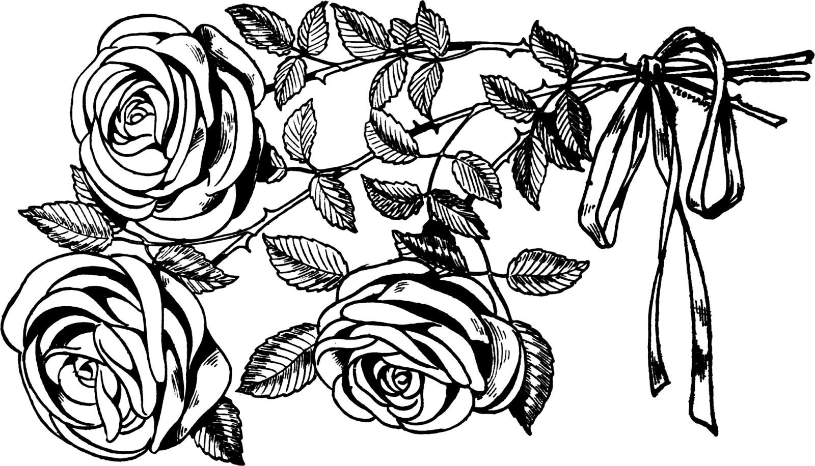

*Metal on Metal*

A shrill shrieking along with hasty percussion;

lyrics nearly unintelligible but my mind shouts abhorrently along.

My soul, every nerve and bone, shakes with rage.

I cannot stand you, your voice, or your name.

I want you gone—out of my life.

Why are you so cruel?

I do not want you in my life,

but it’s not as easy as littering you next to a trashcan.

I do not deserve this,

not anymore. Toodles.

The tunes still pummel in my head

as I try to cut out your jerking and shouting.

Your constant nagging and disrespect tries so hard to seep through.

A mosh pit stirs and circles as I attempt to knock you out

with the loud, annoying anger that rushes and pushes around.

Why don’t you just go?

Here. I’ll even show you out.

I hope you got a good long look

because I promise you,

you are never welcome back

And the song fades

as the screen door slams shut.

*Take a Hint and Leave*

I want to make you stutter. To feel the fear and pain you fuse into me. You don’t realize what it does to a person after so many days, years even—not a clue.

Gas-lighting. Heard of that for the first time a few weeks ago. A term I have experienced for a long while, but never had the word for it. If you don’t know it, just know your photo is plastered next to the definition.

I can’t seem to get you out of my head. I miss my own thoughts. Unfortunately, you still fucking guide them.

You don’t make me feel bad about myself (like you used to). You don’t destroy me (like you used to). You anger me (more than before). You and your voice are like my brain synapses, triggering me and my body into affliction and, boy, does my right arm want to punch a wall in.

You.

I don’t know how else to make this clearer, so listen:

You are no longer welcome. I shouldn’t have even allowed you to enter. No longer are your cunning, manipulative ways even tolerated near me. No. I do not respect you, for you don’t respect me. No.

I wish you were gone, but for some reason you never seem to quite disappear. Once I finally get you to leave—you forgot your purse.

*This poem was written while listening to loud, angry music while I was upset with a “friend” for being blatantly disrespectful.*

*I Blacked Out a Bit*

When I’m given some shitty remark the minute I see someone, I’m going to get pissed. I made a quick errand, and came to back to Kari in my spot, logging me off, and telling me “If you don’t work, you don’t get a desk.” I’m like “Fine, whatever.” But really. Way to be a bitch about it. She would never have done that to anyone else in the office. So why the hell does she feel the ability and nerve to do that to me? I’m really sick of how she treats me sometimes. “She always shows being a good friend to you.” My Ass ! Fuck off. I wouldnever have done that want to hear her voice or anything today. I’m so sick of her snotty ways. And that’s exactly why I feel like I don’t need her as a friend. Friends consider each other’s feelings, they mig ht be rude and heckling sometimes, but this is full assertiveness and rudeness. Nowhere was there a joke or laughter. Since we started this new semester wat the writing center, Kari has asked to block so many days and hours off, or asked me or someone tales to work them. Last semester she threatened to quit and begged for more hours. Now she’s got them and doesn’t seem to want them. She has canceled at least once a week if not two days a week since the new semester started. There may have been one week since the start that she didn’t take any days off. I’m so sick of her bitching and complaining about this and that. She got all bent out of shape when a client came in and got upset that she wasn’t there to tutor him. I would be pissed too if I was told that my doctor wasn’t there for my appointment and I had to either wait an hour or two or reschedule. I’d be pissed off. Luckily, the client was kind and it was okay with them, even though he found it an extreme inconvenience and didn’t really want to stay or reschedule. How trusting is a person who either doesn’t show up or cancels all her hours? At Gastropub? I would have to explain why I couldn’t work and find someone else to take my hours. I also I would not have a job anymore if I didn’t show up to work on ti me. I’m pretty sure she was on a date with Tiffany. I know she said som ething about how she wanted to spend more time with her. I think she’s been taking off hours because of that reason. I know this week she said her family is coming to town so she’s taking off this Thursday and Friday. Last week her great uncle died. A couple weeks ago, I know she said that she was going to do on a date with tiffany, so she blocked her hours again. I have tons of extra hours, not that I’m complaining. But she bitched me out nearl y an entire semester about how this is a professional workplace setting and I need to treat it as such, and she is acting like she can take time off when ever, show up, whene ver, and nothing is wrong with that. She even sai d she hates this job and if she had to be at school longer, she wouldn’t be here because she doesn’t like it and she feels she doe sn’t do a good job because of it. She has the most disgusting case of senior ritis and the worst fucking attitude this semester. That’s also gotten me pissed off too. She has all this anxiety for getting good grades in general. Now she has checked, out, doesn’t want to do any work, and is complains about being anxious of grades and doing good and maintaining a good GPA. Bitch. It’s a one-sided street. Either don’t do anything and live with the shitty grades or put effort into school like a grown-up student knows to do and get the grades you want. I don’t care if you’re anxious anymore. If you put in the work, you’ll get what you deserve. You’ll also get what you deserve if you don’t do the work. Your choice, but quit making it other people’s problem. .

*This poem was taken from an angry journal entry. I blacked out all but a few words to get to the heart of my feelings and depicting who this person is.*

*A Eulogy for You, Stupid Bitch*

The whirling craziness of abhorrent anger and upset.

You placed this within me. I am not happy.

Storms have shaken a normal calm soul.

You have no respect for me.

I no longer trust you.

There’s not physical proof, but the inside pain continues to pierce me.

Friends support equally as a ship and the sea support one another.

Not only have you drilled a hole in the bottom of our boat,

but you poured buckets of water into it.

I cannot stand you.

You tormenting, bitching human.

I have had it—your absolute anguish, your complete dismissal of me.

I am done with you. I am taking what is mine from you.

You do not deserve to treat me this way.

I am sorry to those you mistreat besides me.

This new world lying before me.

Not only are you no part of it,

you are not even a thought bubble.

The vegetation blooms in bountiful colors here

without your dark, ugly clouds.

The waters are calming. The breeze sounds like meditational

instrumental music.

This is how it needs to be:

Your bloody crassness melts into the pavement behind me

as I walk peacefully ahead, toes in the grass,

away from you.

*This poem was written directly for the person who hurt me as well as a true eulogy because they are dead to me. Even though eulogies are supposed to be nice, mine steps away from that “requirement.”*

*True Colors*

People think true colors are bright

“like a rainbow” as the song goes.

But those are the colors

of those who earn them,

embrace them and build them.

Some people’s colors

don’t shine so bright:

The warm reds of pride and passion are just crimson-stained blood-splattered sidewalks.

Pastel and sunshine oranges of cheerfulness and admiration glow as the color of a rotten corpse.

Enlightened spirits of sheen yellows instead ooze cruddy pus and infection.

Technicolor shades of green, saturated with life and positivity, actually grow the greens of mold and battery acid.

Blues of boldness and ambition dirties into a polluted filthy lake.

A bouquet of purples, loyalty and honesty, becomes a large, feisty bruise.

Slick black of confidence turns to a greasy black oil spot.

See, those colors aren’t so pretty

once taken apart and dissected.

If these were the colors of the rainbow,

we wouldn’t love them.

*The idea of “true colors” popped into my head, and I thought to myself, “. . .but not everyone has beautiful colors within them. Some people have truly ugly colors.*

*Part Two:*

*Toxicity Removal*

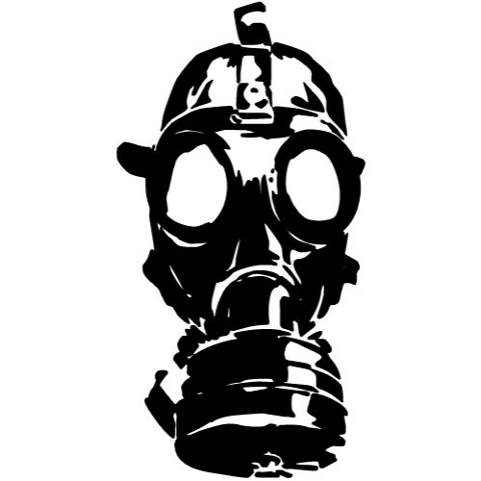

*Never Take Me Down*

My journey never ends

especially in your evil hands.

I will not allow you to violate my

heart, mind, or soul again.

I have eliminated you,

your rude attitude and hatred.

Have a comment? Torment yourself with it.

I no longer have the ears for animosity.

In my mind, you are dead to me

as much as you kill my good vibes.

Every day was a struggle until I let

all the energized anger go.

Think what you will. You’re going to anyway.

Now you have no target.

The only one left is you.

Masterfully try to bring me down again.

I dare you.

But every time, I become stronger.

Don’t think I’ll forget your destructive ways.

I’ll make sure it’s obvious that I’ve conquered them

again and again.

Wonder why I sound hostile towards you?

Look in the mirror—

the negativity alone will crack it into shards.

*This poem was also a message I would’ve liked to tell the person I was/am in conflict with.*

*Moving Target*

What you need? I have.

What you want? I possess.

What you hate? Is mine to enjoy.

Bite me, Bitch.

What I am? You wish you were.

What I do? You could only imagine.

What I adore about myself? You despise.

‘Cause you can’t achieve it.

I’m fierce.

Confident.

Fuckin’ marvelous.

You try. I do.

You push. Bitch, I pull.

You knock me down… Not only am I going to stand taller than before,

but you’re going to feel so small looking back up at me.

No. I won’t attack.

I won’t hit or hurt.

At least not like you did.

No. I’m a gentle queen.

I’ll let you do it to yourself

like you already do.

*This poem was based off of a conversation I had with myself while I was crabby with someone who thought lowly of me.*

*Forever Strength*

Do your worst to my forever strength.

Throw shit, punch, kick, scream, holler, bite

me.

Yet… you never came close to my forever strength.

Because you don’t have forever strength.

You probably never will, for

Forever strength cannot be made with

hate, anger, negativity, pain, or revenge.

Forever strength constructs itself with

love, positivity, pride, self-care, and confidence,

five of which you don’t have,

five more reasons why you destroy others.

So you can come for me,

if you sum up the courage to try me again,

but remember what happened the last time

you messed with my forever strength.

*This poem was based off of a conversation I had with myself while I was crabby with someone who thought lowly of me. (Same as before.)*

“*Hate is a strong word*”

that’s why you employ it.

You tear apart,

seam by seam,

the relationships you’ve sewn.

Others you don’t

even get to know

for who they really are,

you disregard they’re even human.

Why do you do this?

To yourself and others?

I mean, who do you think you are?

Taking perfectly wonderful people

and obliterating them before

they even get the opportunity to introduce themselves?

Well, having known you for four years,

I can tell you:

I hate you.

*While reflecting who this person I have been mentioning is as a person, I had to write the words “I hate you” towards this person because this person lost all my trust and respect.*

*I Send You Off*

The weight is off my shoulders

the pain of a thousand boulders

shaken off like autumn leaves

finally breathing in the breeze

Without you here in my life

I no longer struggle, no more strife

because you’re gone I can finally see

I can be who I need to be

So long to you, my once dear friend

I’m so glad this had to end

but there’s one thing I learned from you:

being strong will always power through

Because you’re wrong, ugly, hateful

I learned to stay ‘way from the spiteful

people like you and those who harm

and some who possess this nasty charm

Nope. I’m gone. Away from hell

where you, hourly, ring his bell,

which reminds me of your spell

that I broke, yet know so well

*I’m not sure what sparked this poem. I remember writing this one in class. I know I wanted something with form, since most of my other poems don’t.*

*Liberation*

Released and pleased

out of the freezing mental medical facility

I burst open the doors—

sucking in fresh, prosperous air

and feeling like I’ve devoured the world.

My mind, once a battlefield,

now explodes with flowers in vivid scents and colors.

The grass ever-so-lightly sways

as my fingers run through the green strands

like an old lover’s head of hair.

Whispering breezes inflate my lungs

as I float among the soft, warmly-shaped clouds

that glide across my view.

I smile as the glowing love from the sun

sings to me: “You are alive and free. Enjoy.”

*This poem was based off of an exercise in Naming the World: And Other Exercises for Creative Writers. The prompt was to write two poems or stanzas; one being calm, one being emotionally charged or energized. Then shuffle the lines between the two and see what occurs. \*\*ADD PROMPT W/ PAGE*

*Part Three:*

*Fueled Up Light Prism*

**

**

**

*Gorgeously Broken*

Shattered light

once together

now cracked

but just as beautiful

maybe even

more so.

*I wrote this when I was bored in Dr. K. Carollo’s Engl. 380: World Literature.*

*I just jotted it down and loved what appeared. I only changed a single word and the alignment between draft one and the final one.*

*Simpler Time*

I used to [catch]

s h o o t i n g s t a r s

with the tip of my tongue

but only when the

r a i n came.

*This was based off of another exercise in Naming the World. \*\*ADD PROMPT W/ PAGE*

*Fair*

daytime:

sticky cement and melting asphalt

cotton candy dollops and cigarettes littered

a commotion of separate jarring noises

a concoction of week-old grease and deep-fried junk

lines for rigged games and unsafe rides clutter the way

bratty, exhausted children and regretful parents

among crowds of teenagers making poor decisions and memories

nighttime:

crispness of the moon’s light shadowing the scattered sea of humans the light—oranges, yellows, greens, purples—flash and swirl hypnotically Farris wheels and tilt-a-whirls filled with couples the ground, like air, carry off pleasant groups of friends to amusement food seems to settle to chili-dogs and grape slushies a 16-year old boy carries his prize, about his size, to his summer fling cheers, laughter, enjoyment harmonize with the shifting of rides and exciting screams

*This was an in class prompt but I don’t remember what it was from………*

*Introduction to Poetry*

That *click-fizz* of a new can of chilled pop

refreshing in a sweltering summer steam

paired with chips and a hotdog—

an effervescent experience

for something so commonly had.

Those days, simple

as a bun and a sausage,

two chips and a slurp of carbonated syrup,

tend to dissipate.

Cold wind and cocoa blow over

like cooling too-hot chicken soup,

which warms

when life doesn’t.

But through the years,

rebounding between seasons

of cider and lemonade,

the experiences,

although sometimes recycled,

never seem to fade.

*This was based off of Ruth L. Schwartz’s “Introduction to Poetry” poem.*

*Kasey*

Fun and games,

a summer day,

out four-wheeling,

turned bleak

in the same moment.

I saw that train

go by. Never even

crossed my mind really

of it having any

significance.

But as the heavy-duty

cars chugged away,

they took something else

in its cargo.

As I crossed over the tracks,

I stopped in a gravel pit

off the road.

All sound ceased to exist.

Any feeling I had

was replaced by matter-less nothing.

I yelled.

I know I did,

but all I heard was silence.

I ran onto the tracks barefooted.

The rocks and splintery wood underneath

my feet were absent.

I pushed her, hoping to see

a sign of life, but the train

took all of that

with the rest of its shipment.

I carried my sweet pet home,

limp in my arms and heavier

than my sinking heart.

*This was based off of a prompt about animals that was based from one of Ruth L. Schwartz’s poems about dogs.*

She was gone.

The train took her.

*Kingston Trio*

A filled college auditorium

I’m the youngest in the whole crowd

in a field of grey and white and wrinkles.

The band—old as Grandma,

who is sitting next to me.

They have their instruments,

glistening in the spotlights.

A few jokes and reminiscing of times past

before they perform.

Every vocal cord—

that saw Vietnam and Watergate,

the moon landing and Columbine,

9/11 and the Regan era,

all in their lifetime—

sung in unison along with the Trio

as if they were 50 years younger.

The pulse of all the bodies

aligned with the notes.

Together we all blended—

the Trio, Grandma and I, all the old fogies—

became a composition

of flashbacks filled with new memories.

*This was a poem I wrote last semester. I felt like it fit with the rest of the poems I had. I worked on it a bit more this semester.*